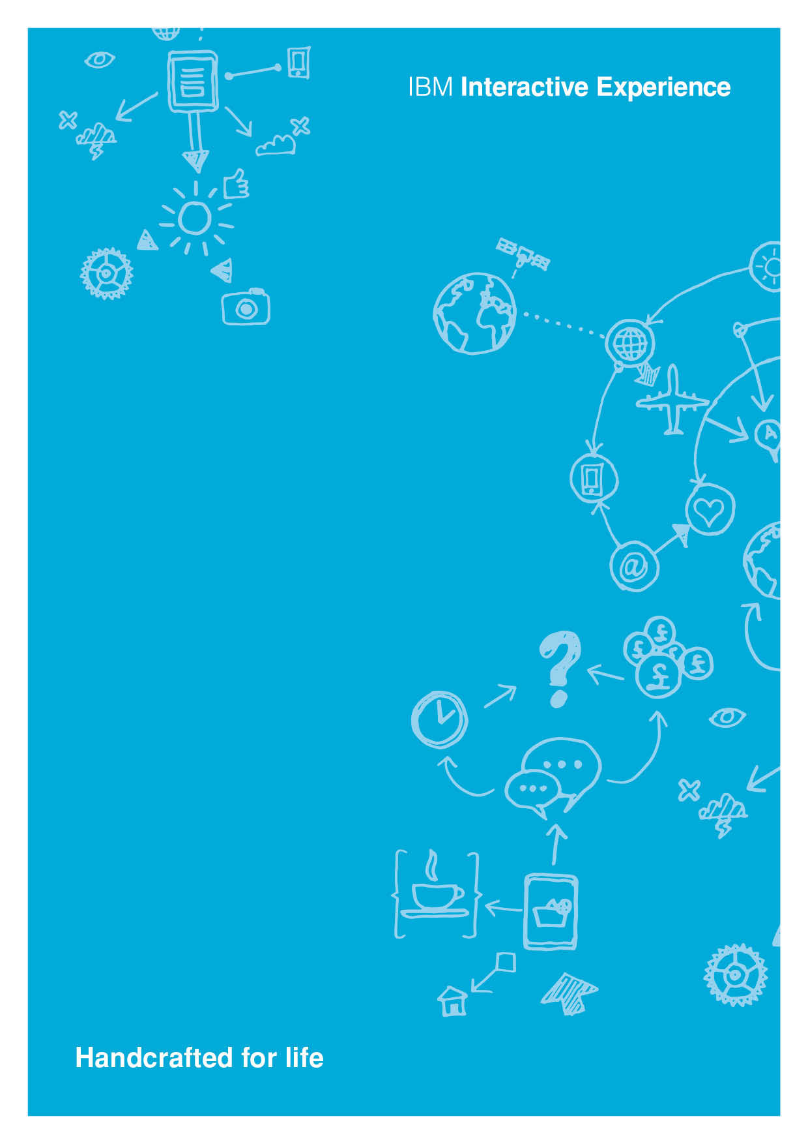Summary

**Hands on workshop, Data Science in the Cloud w/ Python, Apache Spark and Machine Learning.**

**Accelerating Digital Innovation w/ Data Science in the Cloud**

<Date>

<Location>

Instructor:

Carlo Appugliese

Data Science Evangelist

IBM is offering a free class for clients and practitioners to learn about Accelerating digital innovation with Data Science in the cloud. This hands on class using the latest open source technologies like (Python, Apache Spark and R). This is a full day of Data Science education focused around performing simple to complex Data Science applications without any steps on setup or platform. The Data Science education focuses on use case, data science method and development of solution in a fully managed cloud platform. The full day of education will focus on Data Science concepts using open technologies like Apache Spark, R and Python developing Machine Learning solution then deploying it in a digital browser based application. This class offers hands on exercises instructed in person by technical specialist.

**Title**:   
"Accelerating digital innovation with Data Science in the Cloud."  **Who should go**:   
"Anyone interested in learning more about accelerating digital innovation by applying Data Science techniques in the Cloud." **Prerequisite**:   
"A working knowledge of Open Source, Data Science and distributed computing, Coding experience is preferred but not required.”

**What to expect**:   
"Expect to spend a full day of lecture and hands on exercises attacking a real-world digital data science use case. In 8 hours you will learn the basic essentials of Data Science and how to create and deploy a digital machine learning solution in the cloud."

**Full Day Agenda:**

8:30am - 9am Breakfast, Socialize

9:00am – 10:00am Kickoff, Overview of Data Science in the Cloud – Digital Acceleration

10:00am – 11:30am Lab 1, Intro to Coding w/ PySpark – Hand on exercise

11:30 pm – 12:30pm Lunch

12:30pm – 2:30pm Lab 2, Intro to Machine Learning – Hands on exercises

2:30pm – 4pm Lab 3, Intro Digital Deployment - Lecture and Hands on exercises

4pm – 4:30pm Wrap up – Feedback from attendees